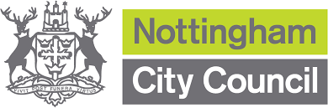

**We want to know how to provide support services for male survivors of domestic abuse.**

Your opinion and feedback will go into a report for the Notts City Council and support services.

This will help improve responses in the future.



All information will be kept safe and your input will be anonymous.

The report will not use your name but may include your words as quotes.

You can change your mind at any point.

**We want to talk and listen to male domestic abuse survivors.**

We will meet safely and sensitively 1-1 or in a focus group with an independent facilitator.

We can pay for travel expenses, provide refreshments and give a voucher to thank you.

We want to make sure everyone feels safe so will make sure support is available during and after talks.



If Interested contact Anna on **07485 352011**

or email **annac@junowomensaid.org.uk**